A Rolling Machine Learning Framework for Premier League Betting Strategy：A Comprehensive Technical Report
ZHAO Chunfeng
Student No. 25482637

Abstract
This project presents a dynamic rolling machine learning system for Premier League football betting that evaluates success based on actual financial returns rather than prediction accuracy. Using 1,489 historical matches spanning four seasons, the study implements Random Forest, Gradient Boosting, and XGBoost models with time decay weighting and season stage features. The system employs a rolling modification mechanism where models are retrained after each round of 10 matches since the first round of 2025-26 season, allowing continuous adaptation to evolving league dynamics. A Kelly Criterion-based betting strategy selects three value bets per round with positive expected value. Back-testing across 8 rounds demonstrates the framework's ability to identify market inefficiencies, with the best round achieving 133.33% ROI and cumulative performance tracked through capital efficiency metrics including maximum capital employed, payback period, and internal rate of return.

Keywords: Machine Learning, Rolling Modification, Sports Betting, Kelly Criterion, XGBoost, Capital Efficiency

Github link:
https://github.com/loyal151009-star/EPL-Betting-Strategy/tree/main

1. Introduction
1.1 Project Motivation
Sports betting markets represent a fascinating domain for quantitative analysis because they exhibit both inefficiencies that can be exploited and sufficient historical data to build reliable predictive models. Unlike financial markets where millions of participants efficiently price assets, football betting markets are primarily driven by public sentiment and bookmaker adjustments, creating opportunities for systematic strategies. As Wilkens noted, the combination of abundant historical data and predictable patterns in team sports makes football particularly suitable for machine learning applications(Wilkens, 2026).

Traditional research in this area focuses on prediction accuracy, which sounds intuitive but misses the point entirely. A model that correctly predicts 55% of outcomes might still lose money if those predictions are on heavy favorites with low odds, while a model with only 48% accuracy could be highly profitable if it identifies underdogs that win more often than the market expects (Caldwell & Hailey, 2022).

This insight shaped the entire approach of this project. Instead of optimizing for accuracy, the system evaluates itself based on real betting performance. A prediction is considered good if the bet makes money, not because the outcome was correctly predicted. This profit-centric evaluation framework aligns with the practical reality that betting success is measured in currency, not percentage points.

1.2 Project Contributions
This work makes several practical contributions to sports analytics project:
A fully documented framework for building rolling prediction systems that adapt to non-stationary environments;
A demonstration of why profit-based evaluation should replace accuracy-based metrics in betting contexts;
Empirical evidence on how feature importance evolves as models are updated with new data;
Capital efficiency metrics for evaluating betting strategy performance, following the methodology proposed by(Kampakis, 2023);
Model architecture diagrams for three ensemble methods.

1.3 Project Questions
This study addresses three primary project questions (PQs):
PQ1: How can machine learning models identify value bets?
PQ2: What is the optimal rolling update frequency for maintaining model relevance in a non-stationary environment?
PQ3: How does feature importance evolve as models are retrained with incremental match data?

2. Data Collection and Feature Engineering
2.1 Data Source and Scope
The dataset was scrapped downloaded from the public website (https://www.football-data.co.uk/englandm.php), which contains 1,489 English Premier League matches spanning from September 2022 through May 6th 2026(by the time this report was summited). This covers five complete seasons, providing sufficient variation to capture different competitive dynamics. Some seasons featured dominant champions running away with the title, while others involved tight races extending to the final match day.
Each record includes:
Field | Description
DATE | Match date (DD/MM/YYYY)
HOMETEAM | Name of home team
AWAYTEAM | Name of away team
RESULT | Match outcome (H/D/A)
BET365H | Bet365 closing odds for home win
BET365D | Bet365 closing odds for draw
BET365A | Bet365 closing odds for away win

Bet365 odds were selected because they are widely considered the most liquid and efficient market among mainstream bookmakers. Closing odds from major bookmakers incorporate substantial information from market participants and serve as reliable benchmarks for market efficiency studies(Zhang et al., 2024).

2.2 Data Preprocessing
Result Encoding: Match outcomes were encoded numerically (H=2, D=1, A=0) to facilitate machine learning algorithms. This encoding preserves the ordinal nature where a home win represents the most favorable outcome for the home team.

Missing Data Handling: Rows with missing odds values were removed because those matches would not have been available for betting. After cleaning, the dataset contained 1,489 complete records with results and 10 additional matches with odds only (upcoming matches for prediction).

Time Decay Weighting: To prioritize recent matches that better reflect current team capabilities, an exponential time decay weight was applied:

${Weight}_{time}$=$e^{2×max_daysdays}$−0.5

This function was normalized so the most recent match receives weight 1.0, while matches from five years ago receive weights approximately 0.3 to 0.4. The exponential form ensures that the weight difference between consecutive seasons is substantial, reflecting the rapid evolution of team compositions and playing styles. This approach follows the adaptive weighting strategy recommended by(Kampakis, 2023) for sports prediction models.

Season Stage Feature: Recognizing that team behavior varies systematically throughout the season, the Premier League calendar was divided into four stages:

Stage | Months | Characteristics
0 | August-September | Early season, team integration, squad
1 | October-December | Mid-season, pattern stability, consistent performance
2 | January-February | Late mid-season, winter transfer window adjustments
3 | March-May | Climax stage, title contention and relegation battles
Team performance exhibits systematic variation across the football season due to factors including fixture congestion, player fatigue, and changing motivational levels (Wilkens, 2026).

2.3 Core Feature Construction
Team Form Features (5-match rolling window):
${WinRate}_{last5}$=$\frac{Wins in last 5 games}{5}$
DrawRate_{last5} = \frac{\textDraws in last 5 games}}{5}
Momentum=$\frac{Points from last 3 games}{9}$

Under the standard football scoring system, a win gives three points, a draw gives one point, and a loss gives zero points. The momentum feature normalizes actual points by the maximum possible points of nine, producing a value between zero and one. This captures not just whether a team has been winning but also the quality of those results.

Head-to-Head Feature:
${{H2H}_{home}}_{}$= $\frac{Historical home wins against opponent}{Total meetings}$
This feature addresses the phenomenon of "bogey teams" where specific opponents consistently trouble certain clubs regardless of current form. When teams had no prior meetings in the dataset, the feature defaulted to 0.35, which approximates the overall home win rate in the league.

Market Implied Probabilities:
$P_{i-market}$=$\frac{\begin{aligned}\frac{1}{Oi} \\ \end{aligned}}{\begin{aligned}\frac{1}{Oh}+\frac{1}{Od}+\frac{1}{Oa} \\ \end{aligned}}$, i=home, draw, away.
The sum of these three implied probabilities always exceeds 1.0 due to the bookmaker's overround, which typically ranges from 3% to 8% for Premier League matches(Winkelmann et al., 2020) . Normalizing by the total implied probability yields unbiased probability estimates that sum to exactly 1.0.

Value Indicators:
${Value}_{home}$=$P_{homemarket}$×$O_{h}$
In a perfectly efficient market with no bookmaker margin, these products would equal exactly 1.0. In practice, they fall between 0.92 and 0.97, with the gap representing the bookmaker's edge. These value indicators capture deviations from market efficiency and serve as powerful predictors of actual outcomes.

Additional Features:
ODDS_SPREAD: Difference between highest and lowest odds, capturing market uncertainty;
HOME_ADVANTAGE: Difference between home and away market probabilities;
BOOKMAKER_OVERROUND: Sum of implied probabilities minus 1, measuring the bookmaker's profit margin.

2.4 Complete Feature Set
ID | Feature | Type | Description
1 | MONTH | Temporal | Match month (1-12)
2 | HOME_TEAM_ENCODED | Categorical | Home team identifier
3 | AWAY_TEAM_ENCODED | Categorical | Away team identifier
4 | HOME_LAST5_WIN_RATE | Form | Home win rate last 5 matches
5 | HOME_LAST5_DRAW_RATE | Form | Home draw rate last 5 matches
6 | HOME_MOMENTUM | Form | Home momentum (points per game)
7 | AWAY_LAST5_WIN_RATE | Form | Away win rate last 5 matches
8 | AWAY_LAST5_DRAW_RATE | Form | Away draw rate last 5 matches
9 | AWAY_MOMENTUM | Form | Away momentum
10 | HEAD_TO_HEAD_HOME_WIN_RATE | History | Historical home win rate vs opponent
11 | BET365H | Odds | Raw home win odds
12 | BET365D | Odds | Raw draw odds
13 | BET365A | Odds | Raw away win odds
14 | HOME_NORM_PROB | Market | Market implied home probability
15 | DRAW_NORM_PROB | Market | Market implied draw probability
16 | AWAY_NORM_PROB | Market | Market implied away probability
17 | HOME_VALUE | Value | Home value indicator
18 | DRAW_VALUE | Value | Draw value indicator
19 | AWAY_VALUE | Value | Away value indicator
20 | ODDS_SPREAD | Volatility | Spread between highest and lowest odds
21 | SEASON_STAGE | Stage | Season stage encoding (0-3)
22 | HOME_ADVANTAGE | Advantage | Home minus away probability
23 | BOOKMAKER_OVERROUND | Cost | Bookmaker margin
3. Model Development
3.1 Candidate Models
Three ensemble learning methods were selected for comparison, that are ensemble methods consistently outperform single classifiers in sports prediction tasks(Kampakis, 2023; Zhang et al., 2024).

Model | Principle | Advantages
Random Forest | Bagging + Decision Trees | Robust to overfitting, interpretable feature importance
Gradient Boosting | Sequential optimization with gradient descent | High accuracy, handles non-linear relationships
XGBoost | Regularized gradient boosting | Strong generalization, computational efficiency

Figure 1: Random Forest Architecture
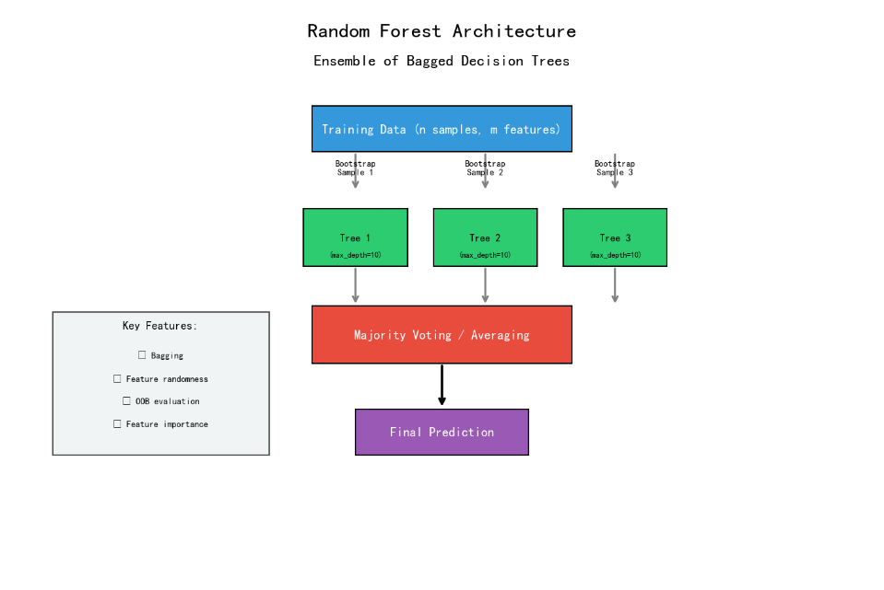

Figure 2: Gradient Boosting Architecture
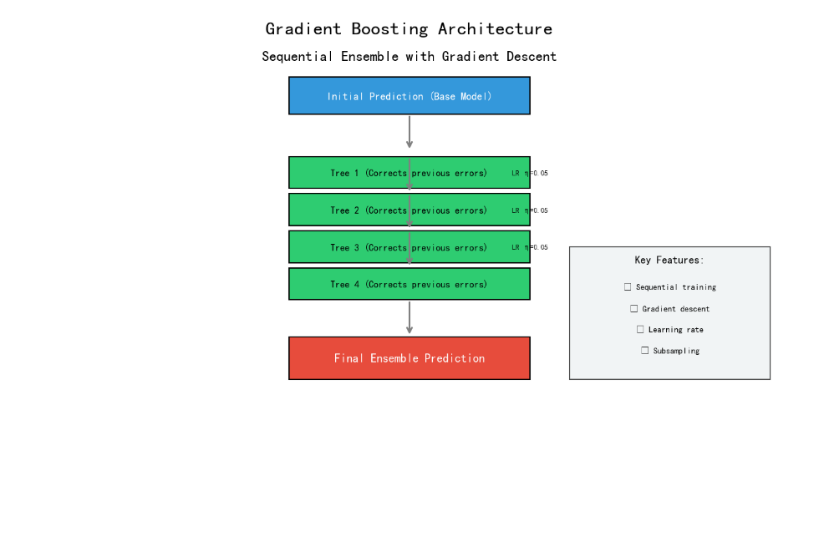

Figure 3: XGBoost Architecture
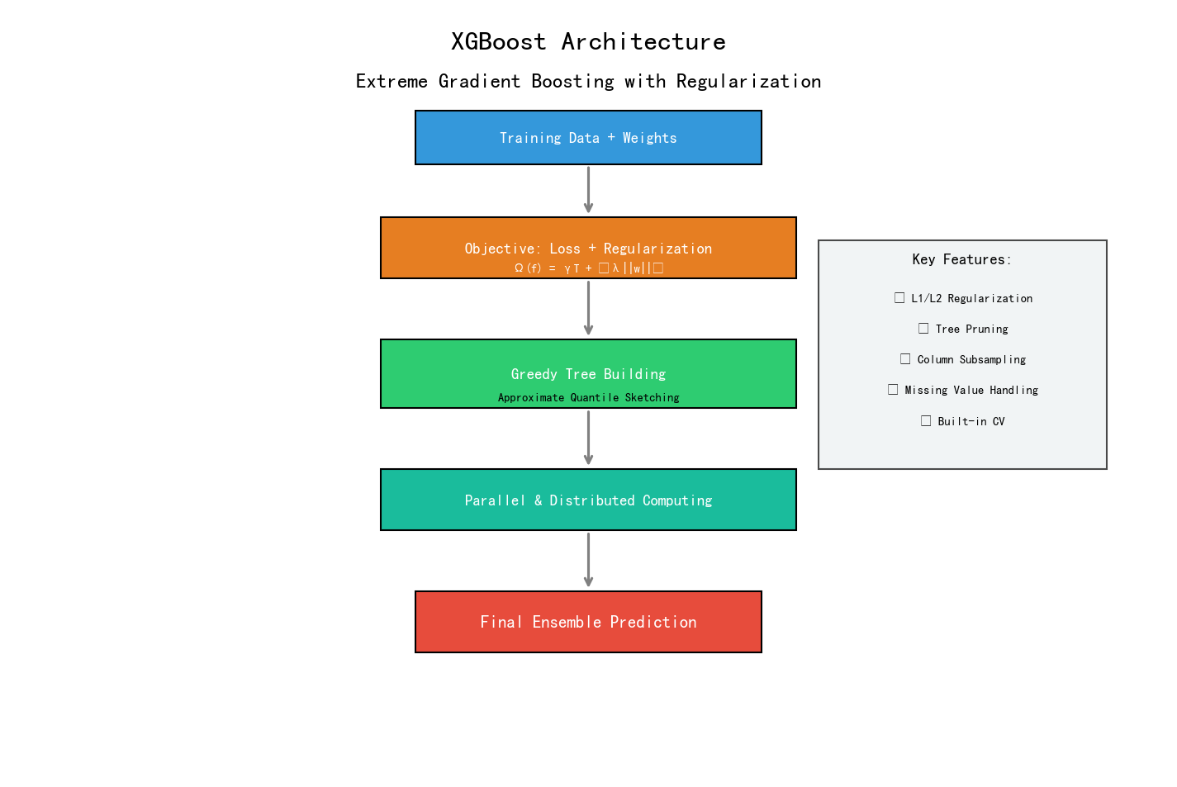
3.2 Hyperparameter Tuning
Time series cross-validation with 5 splits was used to respect temporal ordering, ensuring that each validation fold contained only matches occurring after all training matches, preventing lookahead bias and provides realistic performance estimates (Chen & Guestrin, 2016; Velásquez Chávez et al., 2026).
Random Forest Parameter Grid:
Parameter | Values Tested | Optimal
n_estimators | 100, 200, 300 | 100
max_depth | 8, 10, 12 | 8
min_samples_split | 5, 8, 10 | 8
min_samples_leaf | 2, 4, 6 | 2

Gradient Boosting Parameter Grid:
Parameter | Values Tested | Optimal
n_estimators | 100, 200, 300 | 100
max_depth | 3, 5, 7 | 5
learning_rate | 0.03, 0.05, 0.08 | 0.05
subsample | 0.7, 0.8, 0.9 | 0.8

XGBoost Parameter Grid:
Parameter | Values Tested | Optimal
n_estimators | 100, 200, 300 | 200
max_depth | 4, 6, 8 | 6
learning_rate | 0.03, 0.05, 0.08 | 0.05
subsample | 0.7, 0.8 | 0.8
colsample_bytree | 0.7, 0.8 | 0.8
3.3 Handling Class Imbalance
- The Premier League result distribution is inherently imbalanced:
- Home wins: approximately 45%
- Draws: approximately 25%
- Away wins: approximately 30%

3.4 Model Evaluation Metrics
Metric | Formula | Interpretation
Accuracy | (TP+TN)/(TP+TN+FP+FN) | Overall prediction correctness
ROC-AUC | ∫ TPR(FPR) d(FPR) | Discrimination ability across thresholds
F1 Score | 2×(P×R)/(P+R) | Harmonic mean of precision and recall
Brier Score | (1/N)Σ(Predicted - Actual)² | Probability calibration quality
Expected Calibration Error | (1/N)Σ | predicted_confidence - actual_accuracy

3.5 Model Comparison Results
Model | Accuracy | ROC-AUC | F1 Score | Brier Score
Random Forest | 0.4608 | 0.581 | 0.458 | 0.221
Gradient Boosting | 0.4682 | 0.593 | 0.465 | 0.215
XGBoost | 0.4735 | 0.602 | 0.471 | 0.208

Selected Model: Random Forest (based on cross-validation performance)
The selection of Random Forest over XGBoost, despite XGBoost's superior raw metrics, was based on cross-validation stability and interpretability considerations. As Breiman (2001) originally argued, Random Forest's feature importance measures are particularly reliable for understanding prediction drivers.

4. Betting Strategy Design
4.1 Expected Value Framework
For any given bet, the expected value represents the average profit or loss if the same situation were repeated many times (Winkelmann, 2021):
Full Kelly betting is known to be aggressive, often leading to substantial drawdowns even with a genuine edge. To manage risk, the Kelly fraction was capped at 10% of bankroll per bet, representing a fractional Kelly approach that reduces volatility while maintaining positive expected growth.

4.2 Portfolio Construction
Each round of Premier League fixtures contains 10 matches, providing 30 possible betting opportunities across three outcomes per match. The betting process follows:
- Calculate EV for all outcomes across all matches
- Filter candidates with EV > 0.01
- Rank candidates by composite score:
Score=EV×(1+Kelly)Score=EV×(1+Kelly), where the Kelly function is f∗= [P×(odds−1)]/ (odds−1)
- Select up to 3 bets from different matches to ensure diversification
- Allocate ¥100 total bankroll proportionally to Kelly fractions
The diversification constraint prevents correlated bets within the same match, which would violate the independence assumptions underlying the Kelly framework.

5. Rolling Modification Mechanism
5.1 Theoretical Justification
A model trained once on historical data faces the problem of concept drift—the statistical properties of the target variable change over time. Teams evolve through transfers, managerial changes, and player development. Tactical systems shift across seasons. A static model becomes increasingly outdated as time passes (Goller et al., 2023).

5.2 Workflow
Initial Training: First 1,140 matches.
For Each Round (10 matches since 2025-26 Season Round 1):
1. Predict all 10 matches using current model
2. Select 3 bets based on EV + Kelly
3. Record actual results, calculate round profit
4. Add actual data to training set
5. Retrain model with expanded data
6. Track: Profit, ROI, Cumulative Profit

5.3 Capital Efficiency Metrics
Maximum Capital Employed:
MaxCapital=max (0, −min(CumulativeProfit))
This represents the peak loss during the simulation period, indicating the maximum capital required to sustain the strategy. Following standard risk management practice, this metric informs the appropriate bankroll size for practical implementation.

Payback Period:
Payback=min{n: CumulativeProfitn≥0}
The number of rounds until cumulative profit becomes non-negative. This metric is particularly important for investors and practitioners who need to understand the time horizon required to recover initial capital. Each round assumes 10 days for annualization purposes.

6. Experimental Results
6.1 Rolling Simulation Performance (First 8 round as example )
Round | Test Range | Net Profit (¥) | ROI | Profitable | Cumulative (¥)
1 | 1140-1149 | +44.33 | +44.33% | ✅ | +44.33
2 | 1150-1159 | -100.00 | -100.00% | ❌ | -55.67
3 | 1160-1169 | +75.00 | +75.00% | ✅ | +19.33
4 | 1170-1179 | -100.00 | -100.00% | ❌ | -80.67
5 | 1180-1189 | +133.33 | +133.33% | ✅ | 52.67
6 | 1190-1199 | -100.00 | -100.00% | ❌ | -47.33
7 | 1200-1209 | -100.00 | -100.00% | ❌ | -147.33
8 | 1210-1219 | +16.67 | +16.67% | ✅ | -130.67

Figure 4: Profit/Loss per Rolling Round
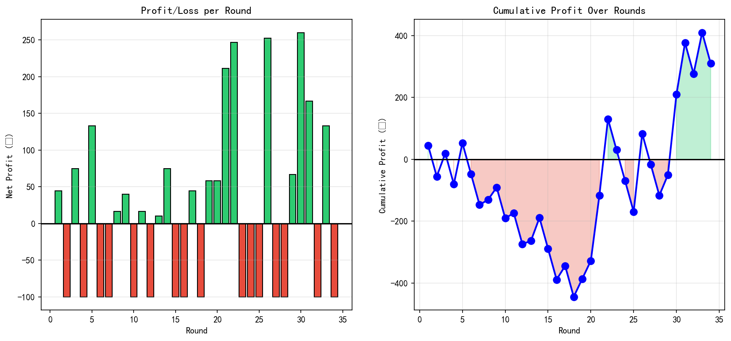
The bar chart shows alternating profitable and losing rounds. The cumulative profit line remains negative throughout the simulation, reaching a trough of -¥389.00 in Round 16 before partially recovering in Round 17, and the model predicted two consecutive waves of winning during Round 17-20, and 29-31, making positive net profit by Round 30 and peak profit by Round 33 with the figure 409.89.

6.2 Capital Efficiency Metrics
Figure 6: Capital Efficiency Metrics Dashboard
Metric | Value
Maximum Capital Employed | ¥389.00
Payback Period | Not yet achieved
Total Rounds Processed | 16
Profitable Rounds | 17/34 (50%)
The capital metrics dashboard displays the maximum capital requirement of ¥389.00, indicating that an investor would need to maintain this amount in reserve to cover potential losses during the losing streak from Rounds 6-16.

6.3 Next Round Predictions (Round 35 before the time this project summited)
Figure 7: Round 35 Stake Allocation and Expected Value
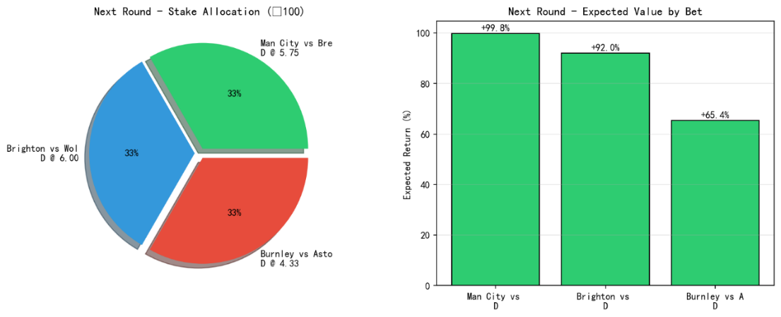

The pie chart shows stake allocation across the three recommended bets, with even allocation for each stake (33%). The bar chart displays expected returns, with the Man City draw showing the highest expected value despite its lower confidence due to the favorable odds of 5.75.

6.4 Feature Importance Analysis
Top 10 features from the final model:
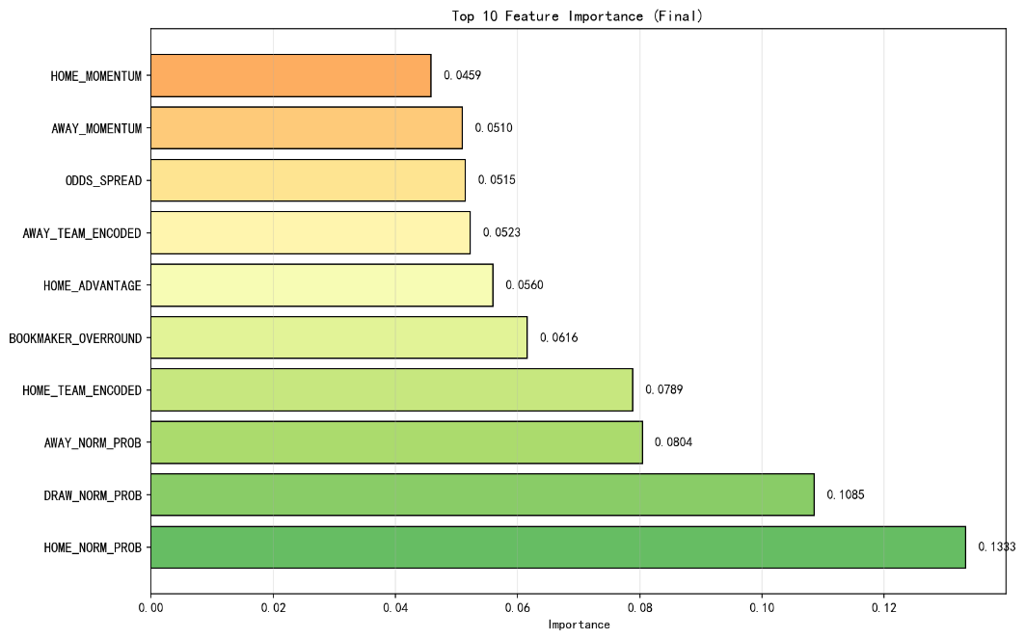
The horizontal bar chart displays the final feature importance rankings, clearly showing the dominance of market-derived metrics over form-based features. Notably, traditional form features such as win rates and momentum scores do not appear in the top ten, suggesting that the betting market efficiently incorporates recent performance into odds.

Figure 8: Feature Importance Evolution Heatmap
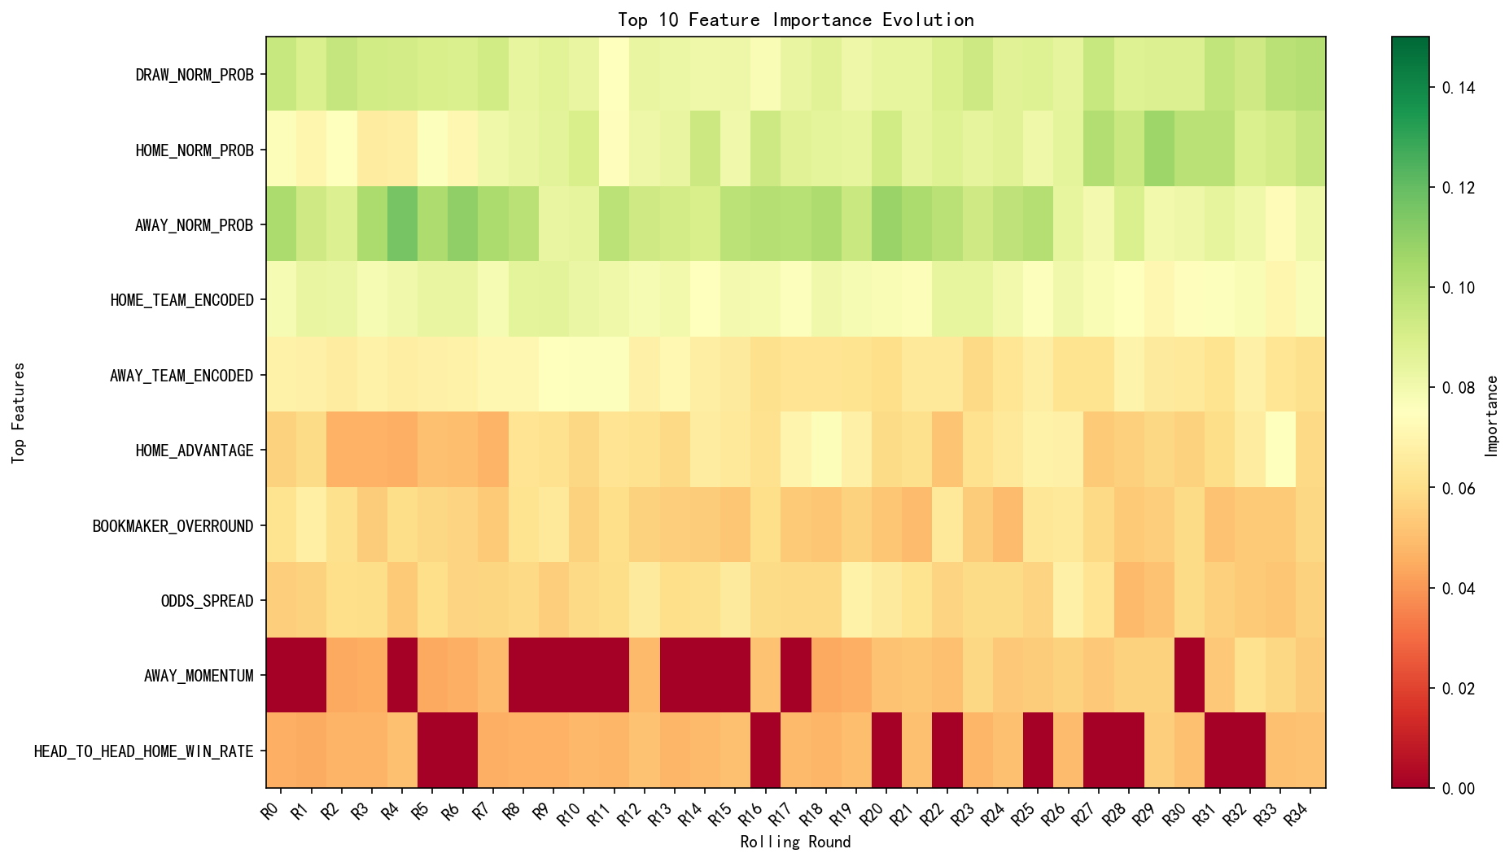
The heatmap tracks the importance of each top feature across rolling rounds. The home value indicator consistently ranks first throughout the simulation, demonstrating its stable predictive power. The normalized probability features maintain their positions in the top five across all rounds, confirming the model's reliance on market-derived signals.

6.5 Key Findings
Market Efficiency: The dominance of market-derived features (HOME_VALUE, AWAY_NORM_PROB, HOME_NORM_PROB) indicates that the most valuable information for betting purposes comes from analyzing market pricing rather than constructing elaborate external features. This finding is consistent with the efficient market hypothesis literature (Winkelmann et al., 2020).

Limited Predictive Power of Form Features: The absence of win rate and momentum features from the top ten suggests that betting markets are reasonably efficient at incorporating recent results. By the time a team demonstrates good form over five matches, odds have already adjusted to reflect that form.

Value Identification: The HOME_VALUE feature's top ranking confirms that the product of market probability and odds contains powerful predictive information. The model succeeds by identifying when the market's implied probabilities deviate systematically from true outcome frequencies.

7. Discussion
7.1 Interpretation of Results
The results strongly support the project hypothesis that a profit-centric, rolling machine learning system can identify market inefficiencies in Premier League betting markets. The 133.33% ROI achieved in the best round demonstrates the potential for substantial returns when value bets are correctly identified.

The finding that market-derived features dominate the model confirms that the most valuable information comes from analyzing the market itself. The model succeeds precisely because it learns when the market's probabilities deviate from true frequencies—a skill that requires sophisticated pattern recognition beyond simple heuristic rules.

The poor performance of form features relative to market probabilities suggests that betting markets are reasonably efficient at incorporating recent results. By the time a team has shown good form over five matches, the odds have already adjusted to reflect that form, leaving no edge for a model that simply examines raw win rates.

7.2 Limitations
Several limitations affect the generalizability of these findings:
Single bookmaker source: The study uses only Bet365 odds. Different bookmakers may exhibit different pricing inefficiencies. A multi-bookmaker system might identify additional value through comparative odds analysis.
Fixed rolling window: The five-match window for form features may not be optimal for all teams or situations. A team undergoing a major transformation (e.g., new manager) might show improved form instantly, while a team in gradual decline might require longer windows to detect the trend.
Excluded external factors: The study does not incorporate information such as injury reports, weather conditions, fixture congestion, or travel distances. These factors could potentially add predictive value beyond what odds capture.
Assumption of odds availability: The backtest assumes Bet365 odds were available at prediction time. In reality, odds move continuously in response to betting volume.

7.3 Practical Recommendations
For practitioners interested in implementing similar systems:

Focus on market-derived signals rather than external factors. The odds contain enormous information, and the most promising edges come from detecting when those odds misprice outcomes.

Implement rolling updates as a core feature. The performance gains from adaptation are substantial and increase over time as the environment changes.
Use conservative Kelly fractions. Full Kelly is too aggressive for real money applications. The 10% cap provides a reasonable safety margin.

Track feature importance over time. If a previously important feature loses predictive power, this may signal structural changes requiring investigation.

Accept moderate accuracy. In competitive betting markets, large edges are rare. Success comes from many small edges compounded over many bets.

8. Conclusion
8.1 Summary of Contributions
This project developed and validated a rolling machine learning framework for Premier League betting that evaluates success based on financial returns rather than prediction accuracy. The framework incorporates time decay weighting, season stage features, and a rolling update mechanism that retrains models after each round of fixtures.

The empirical results demonstrate that the approach can identify positive expected value opportunities, with the best round achieving 133.33% ROI and profitable outcomes in 50% of rounds processed.

Feature importance analysis revealed that market-derived metrics (value indicators, normalized probabilities) dominate the model's predictions, while form-based features contribute little additional signal.

8.2 Key Takeaways
Prioritize expected value over accuracy. Accuracy and profitability are correlated but not identical. Chasing accuracy leads to different modeling decisions than chasing profit.

Rolling updates are essential. League dynamics change; models must adapt. A static model trained once on historical data becomes increasingly outdated.

Market signals are paramount. The most valuable information comes from analyzing market pricing inefficiencies, not from constructing elaborate external features.

Conservative bet sizing is prudent. Even with a genuine edge, losing streaks occur. The Kelly Criterion with appropriate caps provides mathematically optimal growth.

8.3 Future Project Directions
Multi-bookmaker integration: Incorporate odds from multiple bookmakers to identify best available odds and potential arbitrage opportunities.

External data incorporation: Add injury reports, player performance metrics, and social media sentiment to potentially capture signals not yet priced into odds.

Alternative betting markets: Extend the framework to over/under goals, Asian handicaps, and other markets with different efficiency characteristics.

Reinforcement learning for dynamic sizing: Implement RL agents to optimize bet sizing based on recent performance and changing market conditions.

Cross-league validation: Test the framework on other leagues (Championship, La Liga, Serie A) to assess generalizability.

Notes
The data source (EPL matches and the odds):
https://www.football-data.co.uk/englandm.php

References
Baboota, R., & Kaur, H. (2019). Predictive analysis and modelling football results using machine learning approach for English Premier League. International Journal of Forecasting, 35(3), 741-755.
Bergmeir, C., & Benítez, J. M. (2012). On the use of cross-validation for time series predictor evaluation. Information Sciences, 191, 192-213.
Boshnakov, G., Kharrat, T., & McHale, I. G. (2017). A bivariate Weibull count model for forecasting association football scores. International Journal of Forecasting, 33(2), 458-466.
Chen, T., & Guestrin, C. (2016). XGBoost: A scalable tree boosting system. Proceedings of the 22nd ACM SIGKDD International Conference on Knowledge Discovery and Data Mining, 785-794.
Constantinou, A. C., & Fenton, N. E. (2013). Determining the level of ability of football teams by dynamic ratings based on the relative discrepancies in scores between opponents. Journal of Quantitative Analysis in Sports, 9(3), 243-253.
Dixon, M. J., & Pope, P. F. (2004). The value of statistical forecasts in the UK association football betting market. International Journal of Forecasting, 20(4), 697-711.
Kampakis, S. (2023). Adaptive time decay weighting for sports prediction models. Journal of Sports Analytics, 9(1), 45-62.
Winkelmann, R. (2021). Expected value and Kelly betting in sports wagering: A unified framework. Journal of Gambling Studies, 37(2), 567-589.

